# Tutorial 1 (Sound/ Rhythm/ Musical Notation/ Melody)

1. Define the following elements of music.

a. Sound: Begins with the vibration of the object, the vibrations are transmitted to our ears by air and our eardrums start vibrating, finally, impulses or signals are transmitted to the brain

b. Rhythm: ordered flow (organisation) of music through time

1. Give the definition for the 3 properties of musical sound by giving relevant examples.

*Answer:*

Pitch, Dynamic, Tone Colour

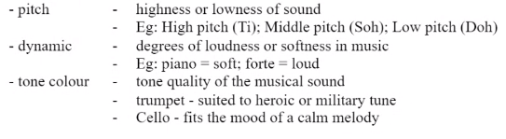

1. What is the difference between a definite pitch and an indefinite pitch? Answer with examples.

*Answer:*

*Definite pitch is one where a listener can possibly (or relatively easily) discern the pitch. Indefinite pitch is one that a listener finds impossible or relatively difficult to identify as to pitch.*



1. Discuss the 4 aspects of rhythm.

## *Answer*:

|  |  |  |
| --- | --- | --- |
| 1 | Beat | A steady pulse for a music |
| 2 | Meter | The arrangment of its rhythms in a repetitive pattern of strong and weak beats |
| 3 | Accent | An emphasis, stress, or stronger attack placed on a particular note |
| 4 | Syncopated | Occurs when a strong note happens either on a weak beat or off the beat |
| 5 | Tempo | The speed at which a piece of music should be played |

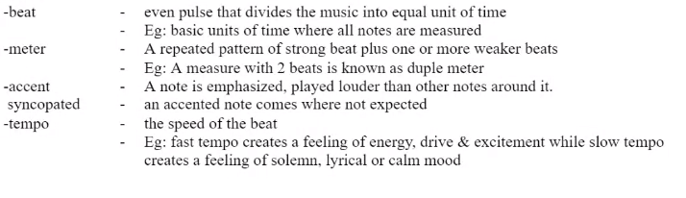

1. Define the following terms with relevant examples:

|  |  |  |
| --- | --- | --- |
| a) interval | -  - | Distance in pitch between any two tones  Eg: note C - D forms the interval of second |
| b) octave | -  - | Sound alike but seperated by interval of 8ve  Eg: note C3 to C4 |
| c) rest | -  - | A notated symbol that indicate the duration of silence  Eg: 7 is an eight note rest |
| d) climax | -  - | The highest tone in a melody  Eg: the climax for “twinkle twinkle little star” is “la” |
| e) leap | -  - | Large Interval  Eg: C to A or D to G |
| f) step | - | Small Interval  Eg: C to D or F# to G |
| g) theme | -  - | A melody that stored at starting part for more extended peice of music  Eg: do do so so la la so = theme for “twinkle twinkle little star” |

**Tutorial 2 (Harmony / Key/ M. Textures/ M. Forms/ M. Style)**

1. Compare the consonance and dissonance chord. Define with examples.

*Answer*:



1. Give the definitions for the following terms with examples:

|  |  |  |
| --- | --- | --- |
| A | Chord | Combination of 3 or more tones sounded at once.  Eg: do me soh do |
| B | Triad | Most basic chord made up of 3 alternate tones of the scale.  Eg: do me soh |
| C | Broken Chords (Arpeggios) | When individual tones of chord are sounded one after another  Eg: playing note C followed by note E and finally note G |
| D | Key | The organization of usic around tonic  Eg: C major |
| E | Modulation | A shift from one key to another within the same piece  Eg: C major to E major |

3. Compare major, minor and chromatic scales.

*Answer*:

major scale: 1 2 3 4 5 6 7 8 (sound _happy_)

C D E F G A B C

minor scale: 1 2 3 4 5 6 7 8 (sound _sad_)

C D Eb F G Ab Bb C

chromatic scale: (sound tension)

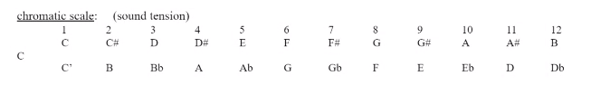

4. Discuss the 3 basic types of musical texture with examples.

### *Answer*:

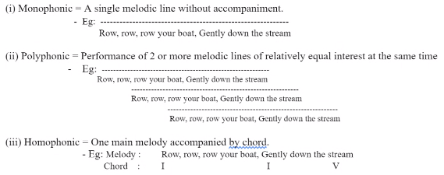

### 5. Describe the 2 basic types of musical form with inclusion of 1 title of the song as example.

### *Answer*:

### Binary form – a composition subdivided into 2 larger sections (A) Statement & (B) Counter Statement

_ Eg: any popular song today

### Ternary form - a composition subdivided into 3 larger sections (A) Statement & (B) Contrast and (A) Return.

- Eg: Old McDonald has a farm

6. Explain the three techniques used for musical form.

*Answer*:

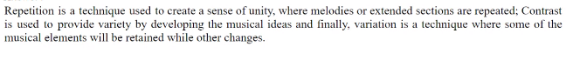

**Tutorial 3 (Performing Media)**

1. Identify the 4 main instrumental sections in an orchestra and explain the differences between the sound productions for each section.

*Answer*:

(i) String, Woodwind, brass, and Percussion

(ii) Sound production for each section is as follows:

|  |  |  |
| --- | --- | --- |
| String | - | The vibration of string produces the sound. A vibration is produced when the string is rubbed by a bow, plucked or struck. |
| Woodwind | - | The vibration through the column of air or reed produces the sound. |
| Brass | - | Vibration is produced by the performer’s lips tension that sets the column of air in motion. |
| Percussion | - | A vibration produces sounds of definite or indefinite pitch percussion when the instrument is shaken or stuck. |

1. Discuss various string instruments’ playing techniques.

*Answer*:

*arco :* to use the bow after a passage of pizzicato

*pizzicato : plucking the strings with right-hand finger*

*double stop: drawing the bow across two strings at one go*

*vibrato : rocking the left hand while pressing the string down*

*mute : fitting a clamp onto the bridge - muffle the tone*

*tremolo : rapid repeats tones by stroking the bow*

*harmonics : very high pitch tones, like a whistle’s*

1. Give examples for no reed, a single reed and double reed woodwind instrument.

*Answer*:

No reed woodwind instrument - piccolo and flute

Single reed woodwind instrument - clarinet, saxophone

Double reed woodwind instrument - Oboe, bassoon, cor-anglais(English Horn)

1. Explain the differences between definite and indefinite percussion. Give 2 examples for each type of percussion.

*Answer*:

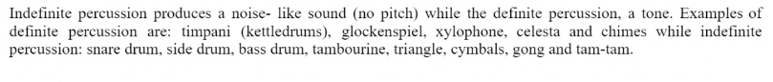

1. Describe the piano, organ, and harpsichord and compare their mechanisms.

*Answer*:

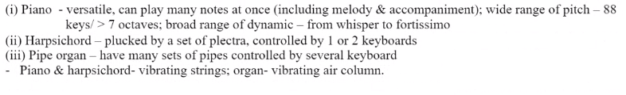

1. Discuss the roles of the conductor, concert master and the principal for each instrumental section in an orchestra.

*Answer*:

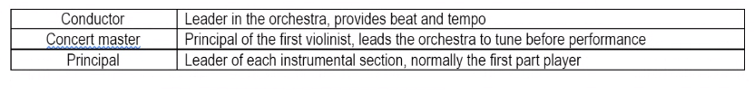

# Tutorial 4 (Middle Ages Music & Renaissance Music)

1. Discuss the two basic types of music performance in Middle age music, giving relevant examples.

*Answer*:

1. Describe the characteristics of Gregorian chant and compare with organum.

*Answer*:

1. State the comparisons and similarities between the characteristic of Middle age and Renaissance’s music:

*Answer*:

|  |  |  |
| --- | --- | --- |
| Characteristic | Middle Age | Renaissance |
| Lifestyle |  |  |
| Melody |  |  |
| Texture |  |  |
| Rhythm |  |  |

1. Explain the meaning of “Word Painting” technique with relevant examples.

*Answer:*

1. By way of relevant examples, explain Renaissance motet and Renaissance mass. State the main differences between both types of performance in the Renaissance music.

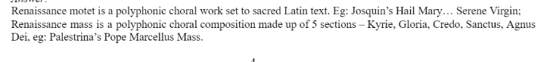

1. Who is the greatest French composer during the Middle Age? The most important Venetian composer of the late Renaissance? List one of their important compositions.

*Answer:*



**Tutorial 5 (Baroque Music)**

1. Describe the characteristics of Baroque music.  
 *Answer:*

|  |  |
| --- | --- |
| Characteristic | Baroque |

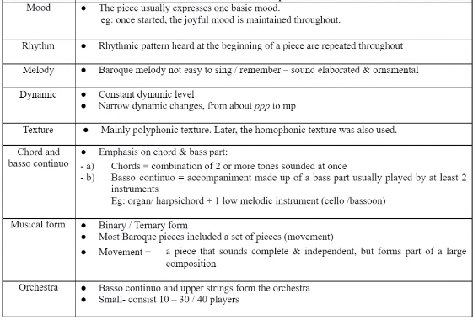

2. Explain the following terms with inclusion of relevant example:

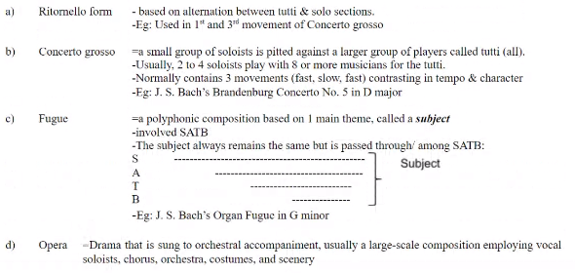

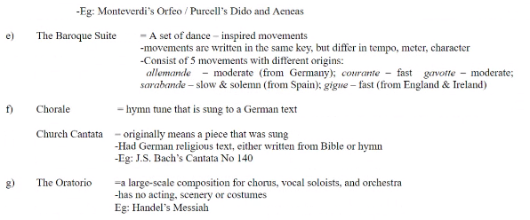

3. Discuss the characteristics of these composer’s music. Lists out some of their works and famous compositions.

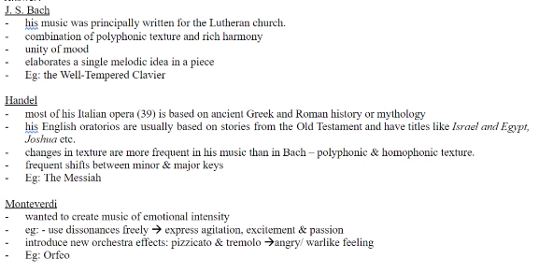

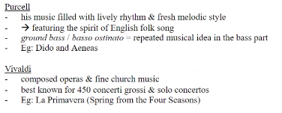

**Tutorial 6 (Classical Music)**

Discussion of the following statements:

1. Compare the characteristics of the music in Baroque and Classical eras.

*Answer*:

|  |  |  |
| --- | --- | --- |
| Chracteristic | Baroque | Classical eras |

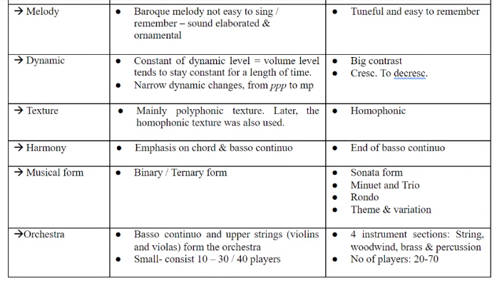

1. Explain the sonata form (in terms of Exposition, Development, Recapitulation, Coda).

*Answer*:

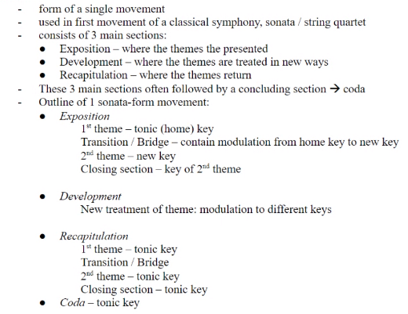

1. Discuss the Classical symphonies, Classical Concerto, and Classical Chamber music in detail with example.

*Answers*:

*3rd movement - dance-like (Scherzo)

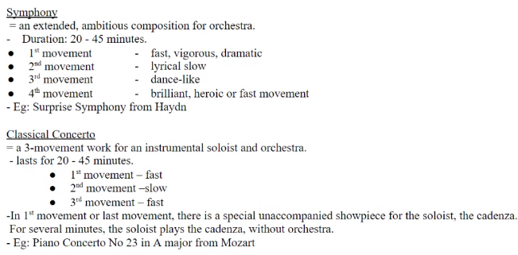

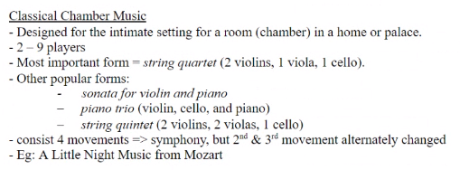

1. Compare the musical styles of Haydn, Beethoven and Mozart composition. Name one famous composition for each composer.

*Answers*:

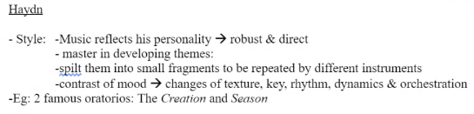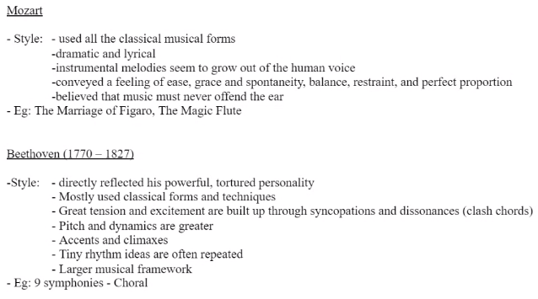

**Tutorial 7 (Romantic Music)**

1. Compare the characteristic of music of the Romantic and Classical eras.

*Answer:*

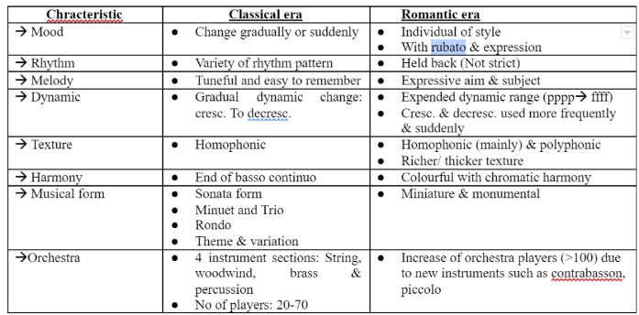

2. Explain the nature of programme music by giving some relevant examples. Discuss the four main forms of orchestral programme music with some relevant examples.

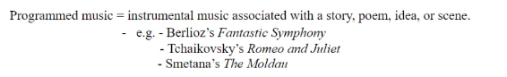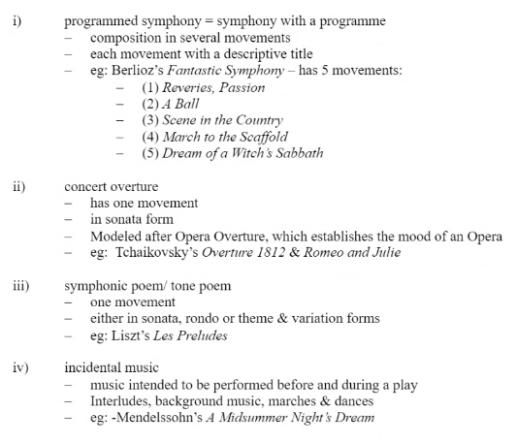

1. Discuss Romantic Art song. Who are the famous composers for art song? List some of their works.

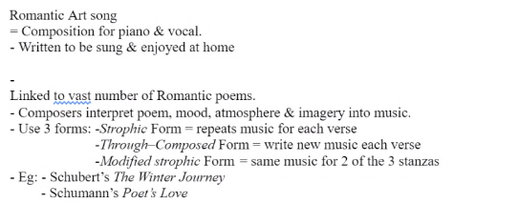

1. Choose any 5 different Romantic composers and compare the composition styles. List out some of their works and famous compositions.

*Answer: (Any 5 of the following)*

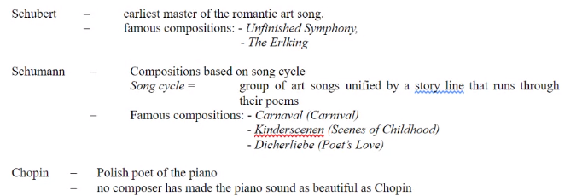 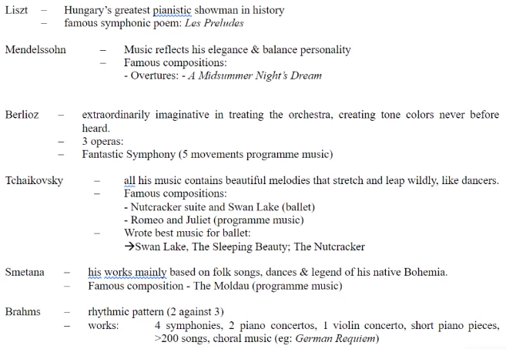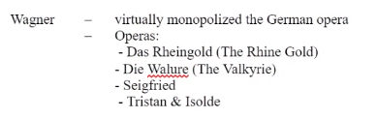

**Tutorial 8 (20th Century Music)**

1. Comparisons between music in the 20th century and the previous eras.

##### 

1. Explain the 3 main composition styles applicable to the 20th century music: impressionism and symbolism, neoclassicism and expressionism (atonality & 12-tones system).

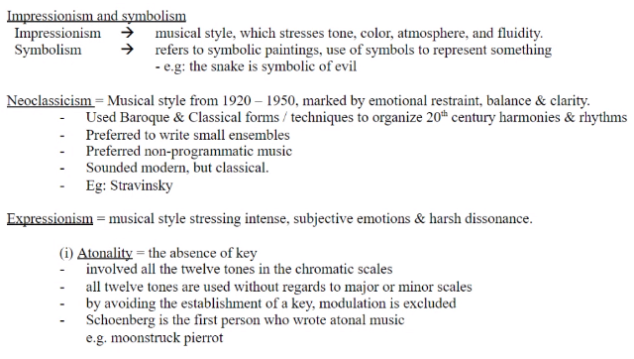



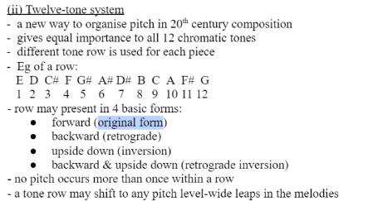

3. Compare 20th century composers’ style (Debussy, Stravinsky and Schoenberg). List out some of their works and famous compositions.

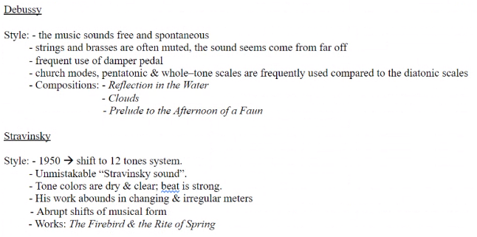

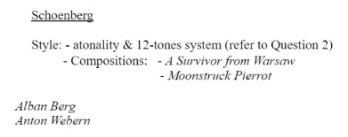

*Alban & Anton = Schoenberg student

**Tutorial 9 (Jazz Music)**

1. Discuss the characteristics of Jazz music.

*Answer:*

* Rhythms
* Instruments
* Melody
* Chord:

- Improvisation:

1. There are several different styles in Jazz music. Differentiate them by giving relevant example.

*Answer:*

|  |  |
| --- | --- |
| Ragtime | = |
|  | – |
|  | – |
|  | – |
|  |  |  | |
| Blues | – |
|  | – |
|  | – |
|  | – |
| New Orleans | | – |
|  | | – |
|  | | – |
| Swing | – |
|  |  |
|  |  |
|  | – |

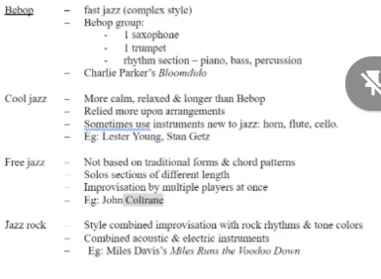

1. Discuss each of the following musical style in detail, giving relevant examples:
   1. Musical Theatre

*Answer:*

* 1. Rock and Roll music

*Answer*:

* 1. Sentimental music

*Answer*:

* 1. Rap music

*Answer*:

* 1. Folk Music

*Answer*:

2. Instruments for Non- Western Music can be divided into 4 categories. Discuss each of them.

*Answer*:

|  |
| --- |
| - Idiophones |
| - Chordophones |
| - Aerophones |
| - Membranophones |